TRAVEL & TOURS

Developer Guide

|  |  |  |
| --- | --- | --- |
| **Supervisor:** | Sir Muhammad Haris |  |
| **Batch:** | 2401G3 |  |
| **Group:** | C |  |
| **Serial no.** | **Enrollment number** | **Student Name** |
| 1. | 1547443 | Miss. Ayesha Naz |
| 2. | 1551007 | Mr. Muhammad Ayaan Mehfooz |
| 3. | 1546909 | Mr. Muhammad Hammad Shahid |
| 4. | 1549513 | Miss. Maliha Tahir |



Home

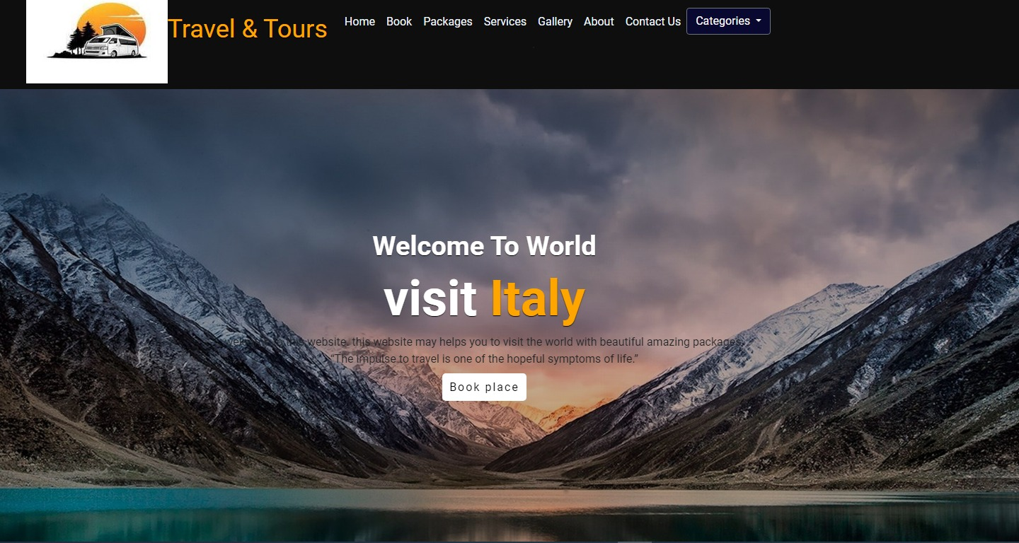

Figure 1: Home Page For Our (Travel & Tours) Website:

Our Slogan has been given to the people toward our website. “Travel & Tours”.

Our homepage welcomes our customers with a beautiful travel quote.

Code Of Home Page

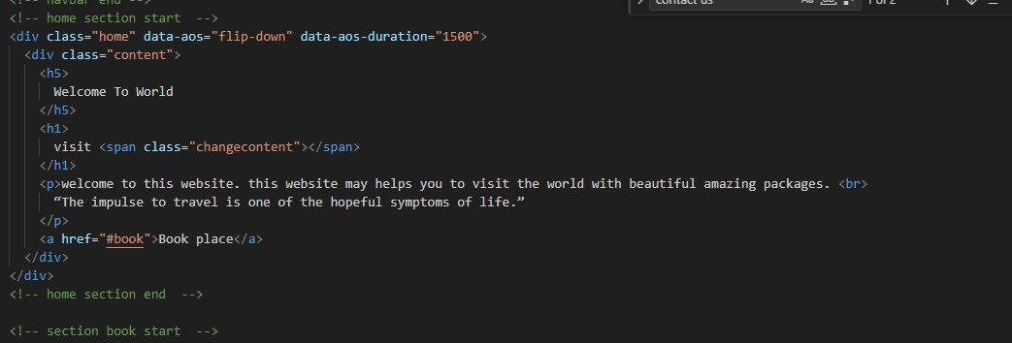

Booking

PAGE OF Booking

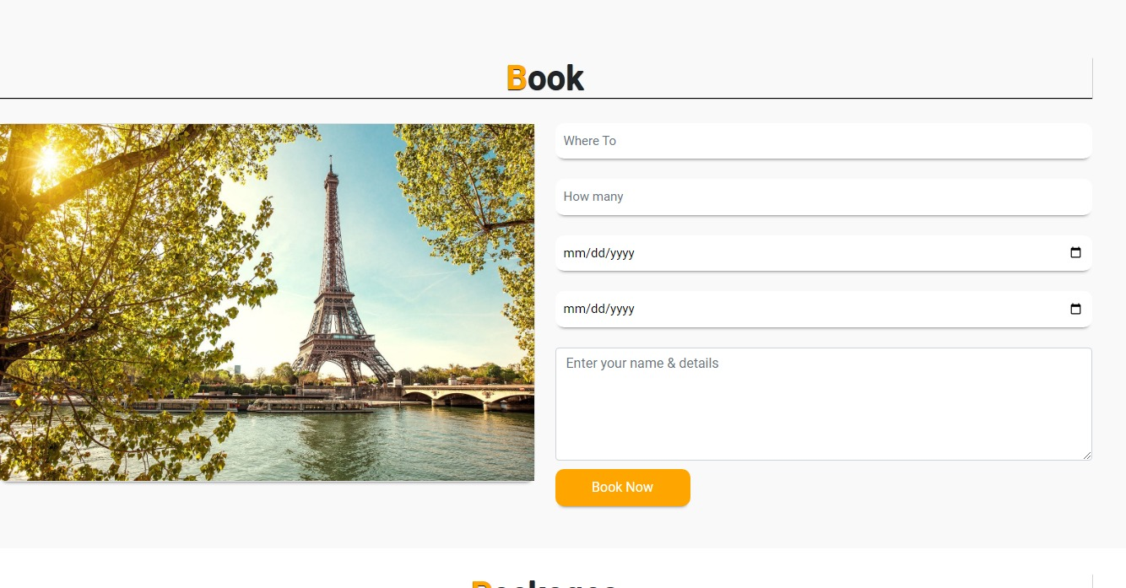

CODE OF Booking

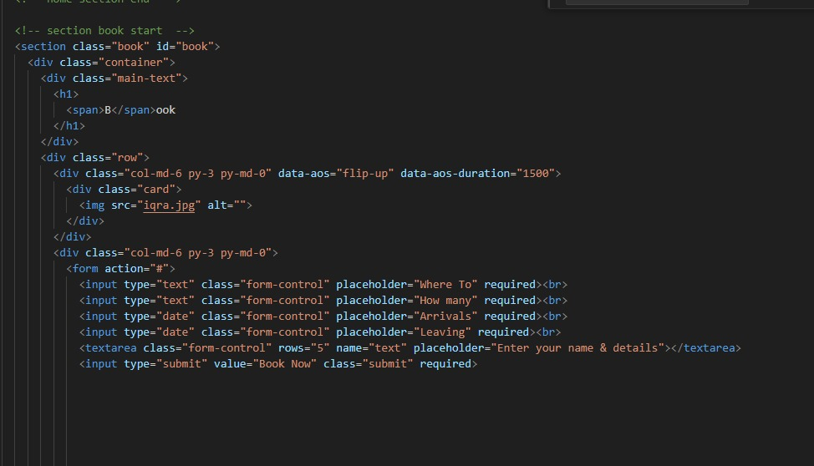

Packages

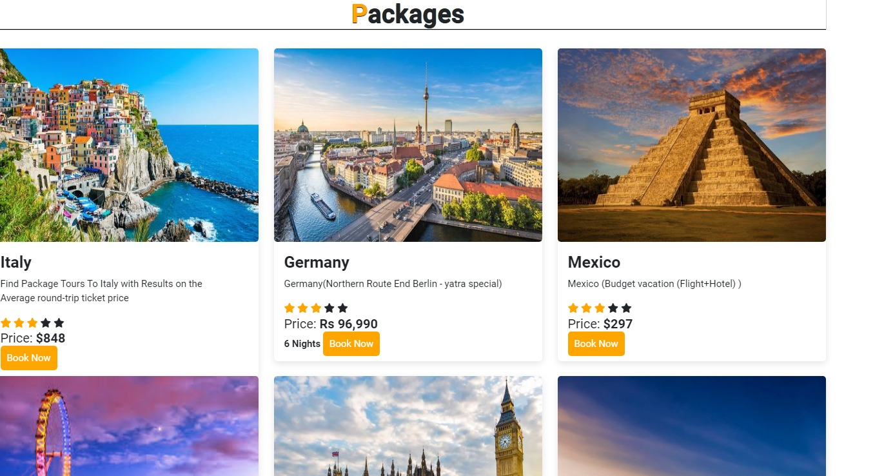

CODE OF Packages

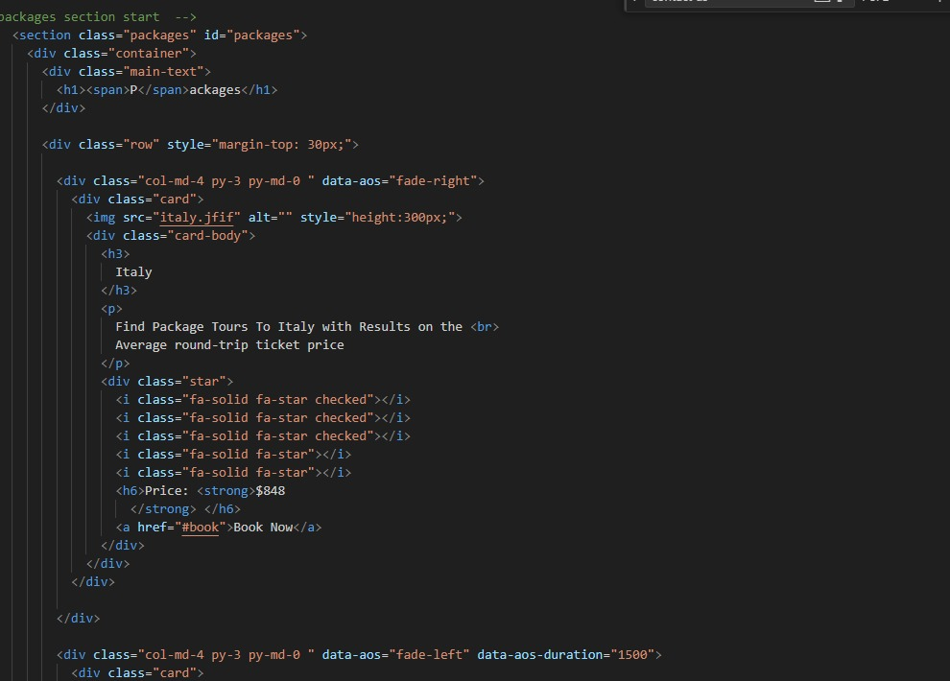

NAVBAR

DESIGN OF NAVBAR



CODE OF Navbar

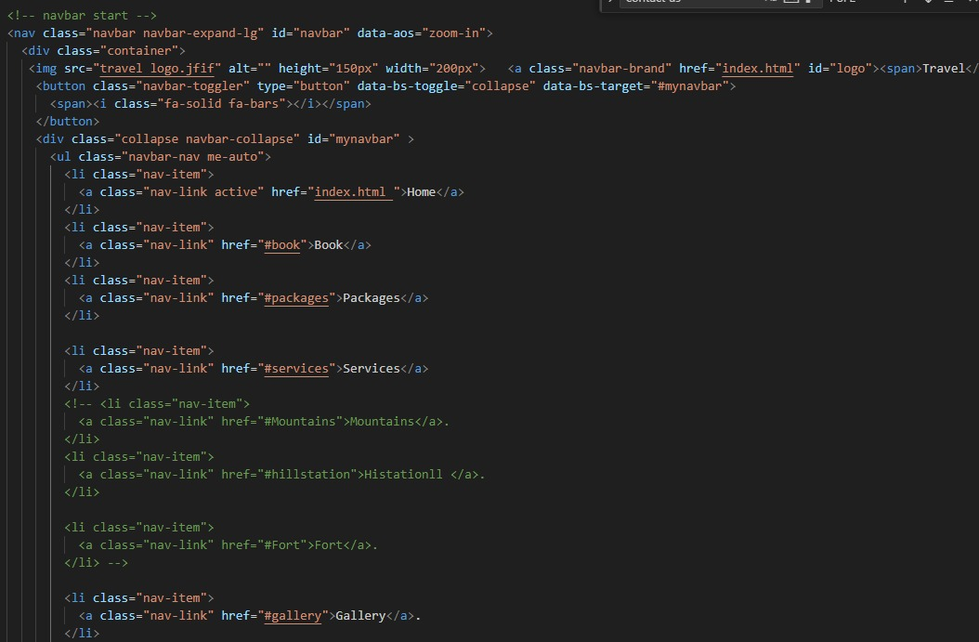

ABOUT US

DESIGN OF ABOUT US

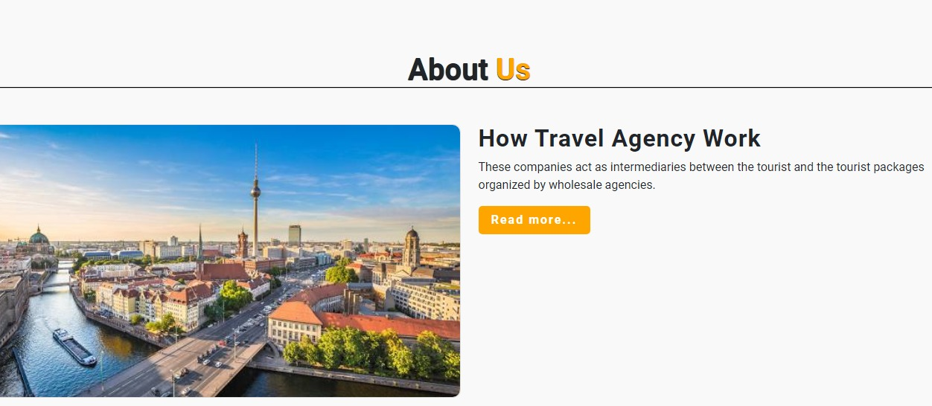

* We offer our users an overview of who we are, our travel journey, and our accomplishments.

(It contains 3 sections)

CODE OF ABOUT US

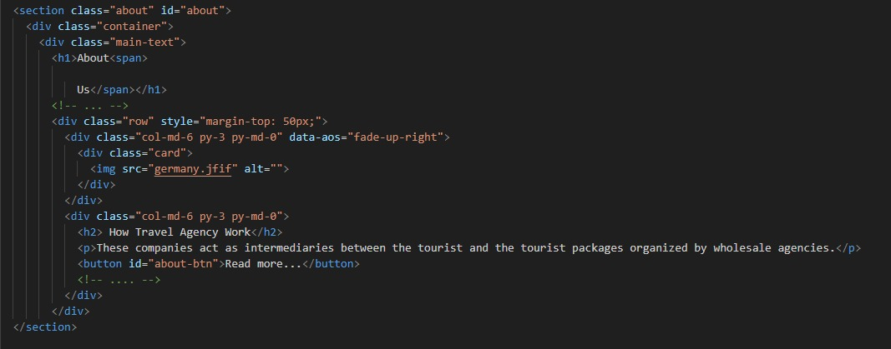

Categories

DESIGN OF categories

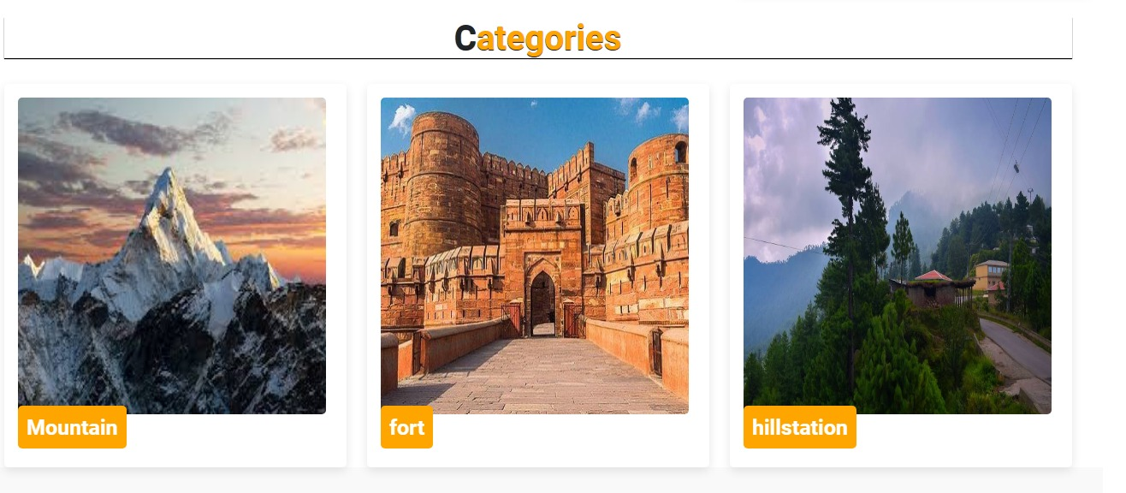

CODE OF categories

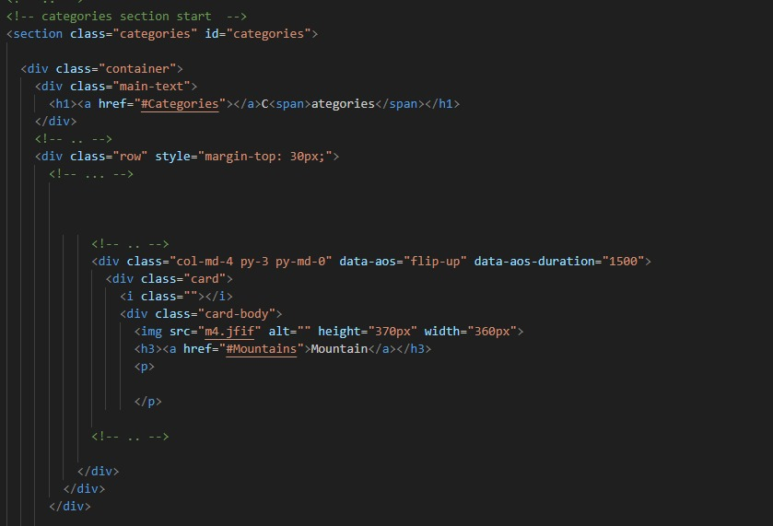

Services

DESIGN OF Services

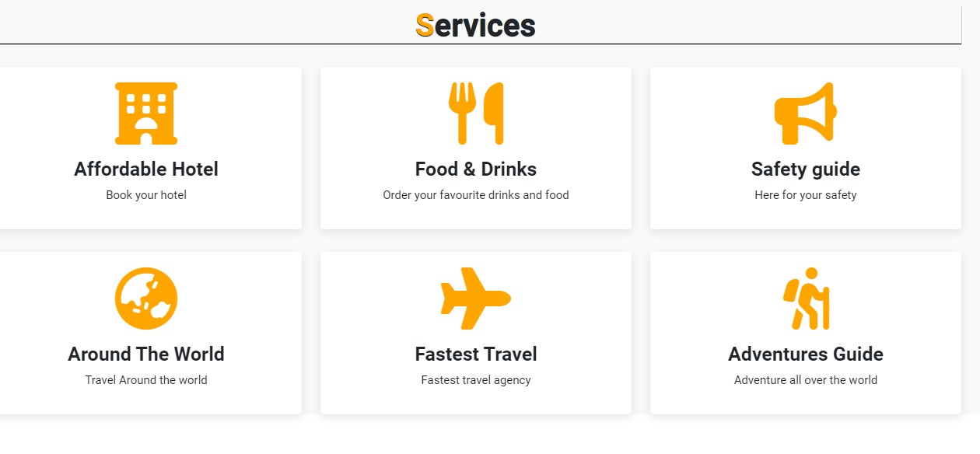

CODE OF Services

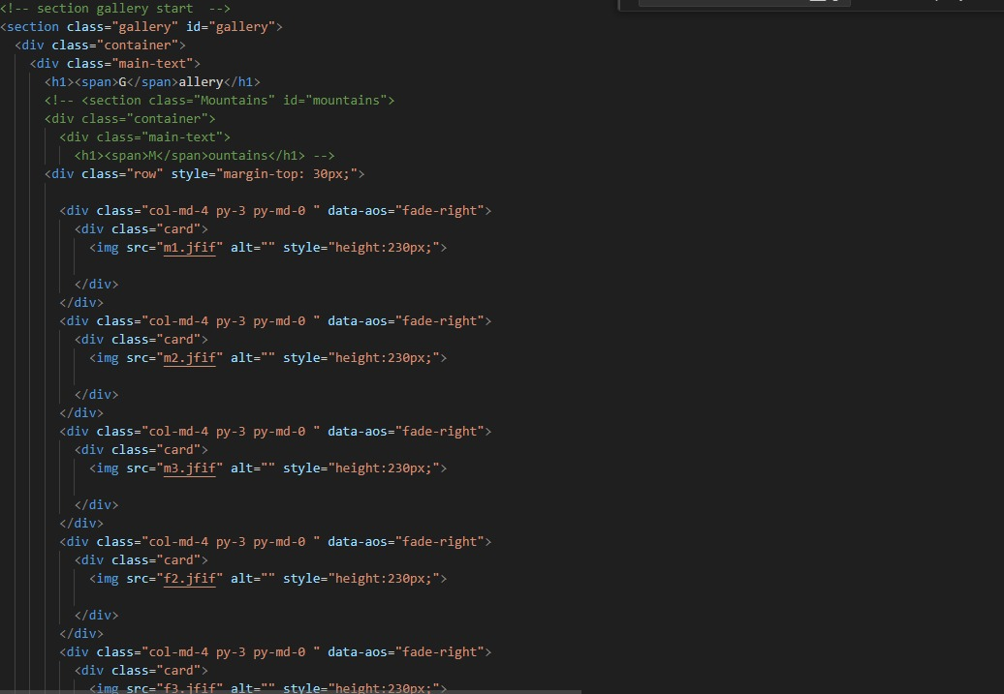

CONTACT US

DESIGN OF CONTACT US

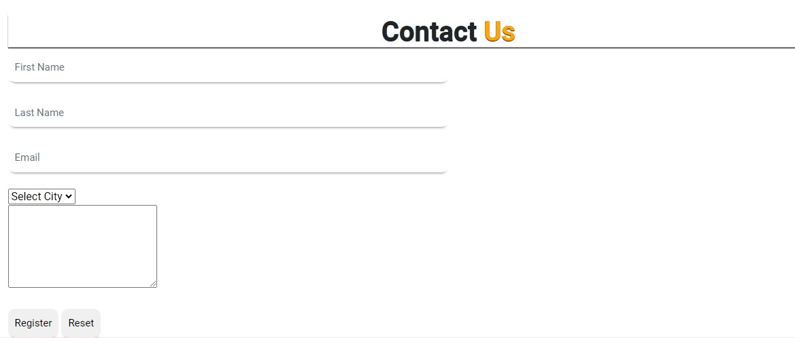

CODE OF CONTACT PAGE

